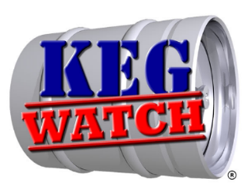

WELCOME TO KEG WATCH LIMITED

Each year the brewing industry loses many millions of pounds through the theft and misappropriation of kegs, casks and dispense gas cylinders (containers). Keg Watch is the organisation committed to reducing these losses.

Keg Watch is a Trade Association limited by guarantee. We represent the interests of over 1000 members from micro to international brewers, cider makers and the major suppliers of dispense gases to the industry.

Our aim is to deliver a cost effective recovery and repatriation operation to the brewing and dispense gas industries, as well as providing security services which combat theft and misappropriation of containers.

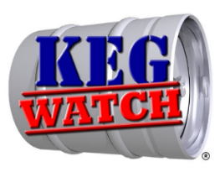
Who are we and what do we do?
- We are a non-profit making organisation with over 1,000 members, ranging from international brewers, regional and family brewers, cider makers, dispense gas companies and SIBA members.
- We are the only company, authorised by the industry, to uplift kegs, casks and dispense gas cylinders (containers) that have fallen outside of the normal distribution channel.
- Membership is free, all we ask is that invoices (should we pick up any of your containers) are paid in a timely manner (30 days), and invoice queries are raised as soon as possible to ensure an early resolution.
- We respond to calls into the Keg Watch admin team for collections and arrange uplift either via your suppliers or our agents. We do not operate a ‘seek and search’ for containers.
- We work with police forces, border forces, local authorities and other government bodies, in an effort to prevent the theft and misappropriation of containers.
- We act on your behalf should any of your containers be involved in any criminal activity/investigation; which includes recovery, examination and storage for court purposes, also providing statements and securing other evidence.

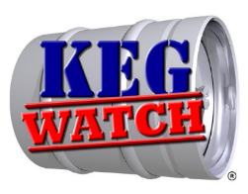

- We provide an on-line system, Spa Trak, to help brewers and cylinder owners track their assets on other brewer/third party distributor yards.
- We maintain a list of accredited scrap metal dealers for brewers to dispose of their own damaged/surplus containers.

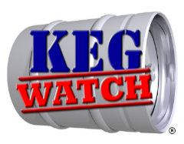
PAYMENT TERMS

Payment strictly within 30 days via money transfer to the following account:-
Keg Watch Limited
Account Number: 10079439
Sort Code: 161470

Or by cheque to:-
Keg Watch Limited
PO Box 5935
Burton on Trent
Staffs
DE13 0YL

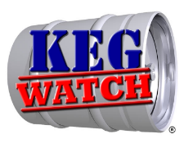
All Keg Watch yards are open 07.30am - 15.00pm Monday - Friday.
Brewers MUST book collections with Sally to gain access.07934719899
You may be turned away if you have not booked in.

Kegspertise
Junction 5,M8 Business Park,
Calderhead Road,
Shotts, Lanarkshire,
ML7 4EQ

Kegspertise
Yard 1
Crigglestone Industrial Estate
Crigglestone
Wakefield
WF4 3HT

Kegspertise
Drakelow Ind Estate
Walton Rd
Burton on Trent
DE15 9UA

G&G GALLO
G&G Gallo,
6-8 Burton Road,
Norwich,
NR6 6AX

Kegspertise
Rag Hill
Aldermaston
Reading
RG7 4NT
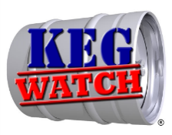

Kegspertise
C/O Kammac 379 Distribution Centre,
Dallam Lane,
Warrginton,
WA2 7NT

SIBA Hubs

Harviestoun Brewery CONTACT
Hillfoots Business Village 01259 769100
Alva Industrial Estate
Alva
FK12 5DQ

Oakham Ales CONTACT
2 Maxwell Road 01733 370500
Peterborough
PE2 7JB

Titanic Brewery CONTACT
Unit 5 Callender Place 01782 823447
Stoke on Trent
ST6 1JL

Cheddar Ales CONTACT
Unit 5 Winchester Farm 01934 744193
Draycott Road
Cheddar
BS27 3RP

Exeter Brewery CONTACT
Cowley Bridge Road 01392 823013
Exeter
EX4 4NX

SIBA members – if you wish to collect your containers from one of the Keg Watch yards or SIBA hubs, once you have nominated your preferred site, we will automatically transfer all your containers to this site. These stock transfers are usually done on a 4 – 6 week basis.

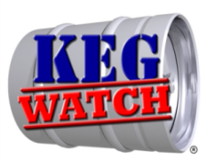
Keg Watch Limited
PO Box 5935
Burton on Trent
Staffs DE13 0YL
Tel: 01283 741274
Email: info@kegwatch.co.uk

Membership of Kegwatch ltd.
All prospective members of Keg Watch Ltd are required to complete this registration form and return by post to;
Keg Watch Ltd. PO Box 5935, Burton on Trent, STAFFORDSHIRE. DE13 0YL or scan to info@kegwatch.co.uk
SECTION 1: MEMBER CONTACT INFORMATION
TITLE |  | FULL NAME
POSITION
COMPANY
ADDRESS 1
ADDRESS 2
TOWN/CITY |  |  |  |  | TEL:
COUNTY |  |  |  |  | MOB:
POST CODE |  |  |  |  | EMAIL:

SECTION 2: ACCOUNTS CONTACT INFORMATION (IF DIFFERENT TO ABOVE)

TITLE |  | FULL NAME
TEL: |  |  |  | MOB:
EMAIL:
SECTION 3: CONTACT FOR KEG/CASK COLLECTION (IF DIFFERENT TO ABOVE)
TITLE |  | FULL NAME
TEL: |  |  |  | MOB:
EMAIL:

SECTION 4: CONTAINER COLOUR BANDS (PLEASE PROVIDE DETAILS OF YOUR COLOUR BANDS)

TOP | MIDDLE | BOTTOM
SECTION 5: DECLARATION
I HEREBY CONFIRM MY MEMBERSHIP OF KEG WATCH LTD AND CONFIRM THAT KEG WATCH LTD ARE AUTHORISED TO ACT ON OUR BEHALF IN HANDLING OUR CONTAINERS (KEGS, CASKS AND DISPENSE GAS CYLINDERS) THAT ARE DEEMED TO BE AT RISK, HAVE BEEN SUBJECT TO THEFT, MISAPPROPRIATION OR HAVE FALLEN OUTSIDE OF OUR DISTRIBUTION NETWORK.
WE AGREE TO MAINTAIN OUR COMPANY CONTACT DETAILS.
WE AGREE TO KEG WATCH LTD PAYMENT TERMS
NAME (PRINT)
NAME (SIGNED) |  | DATE

